**Introduction**

Robotics provides a physical application of the programming and problem solving skills acquired in the previous units. The LEGO® Mindstorms NXT software uses drag and drop programming which will provide a natural transition from Scratch. Robots are shared by several students which will emphasize the collaborative nature of computing. In order to design, build and improve their robots, students will need to apply effective team practices and understand the different roles that are important for success.

Discussing the features of robots provides an opportunity to emphasize how computing has far-reaching effects on society and has led to significant innovation. Students can discuss such topics as:

* The effects innovations in robotics have had on people.
* The significance of processes that have been automated because of robots.
* How innovations in robotics have spurred additional innovations.
* The unit consists of three main sections:
* The features of robots (Days 1-3)
* Familiarization with the robot and the software (Days 4-13)
* Robotics projects (Days 14-33)

Throughout the unit the similarities and differences between Scratch and the programming needed to move the robot can be highlighted.

Specific topics for each instructional day are listed in the overview chart on the next page.

|  |  |
| --- | --- |
| **Daily Overview Chart** | |
| **Instructional Day** | **Topic** |
| 1 | What is a robot? Identify the criteria that make an item a robot. |
| 2-3 | Evaluate robot body designs and create algorithms to control robot behavior. |
| 4 | Set up LEGO® Mindstorms® NXT® kit. |
| 5 | Build robot base. |
| 6-7 | Introduce the features of NXT Brick—the “brain” of the robot. |
| 8-9 | Introduce the features of the Mindstorms NXT software. |
| 10-13 | Program the robot using the Mindstorm Robot Educator Software tutorials. |
| 14 | Introduce RoboCup real life robotic competition and write instructions for tic-tac-toe |
| 15 | RoboTic-Tac-Toe Tournament and introduction to RoboCupJunior Dance Challenge. |
| 16-18 | Build, program, and present a dancing robot. |
| 19-23 | Build program and present a rescue robot |
| 24-33 | Final projects and presentations |

**Daily Lesson Plans**

**Instructional Day:** 1

**Topic Description**: “What is a Robot”? Identify the criteria that make an item a robot.

**Objectives:**

Students will be able to:

* List and explain the criteria that describe a robot.
* Determine if something is a robot, using the criteria.

**Outline of the Lesson:**

* Brainstorm about robot definition (10 minutes)
* “Kismet” video (5 minutes)
* Elements of a robot (10 minutes)
* Am I a Robot? Activity 1 (15 minutes)
* Student group work—Are we Robots? (15 minutes)

**Student Activities:**

* Brainstorm what they think of when they hear “robot” and then identify common features of robots.
* Participate in whole class activity determining if common items are robots.
* Work in small groups to complete “Are we Robots?” activity.

**Teaching/Learning Strategies:**

* Brainstorm: Ask students what they think of when they hear “robot”. Display responses. Responses may include the following:
* Movie and TV robots such as Wall-E, iRobot, Robots, Rosie from The Jetsons
* Modern industrial robots such as those involved in assembly-line factory work
* Mars Rovers
* iRobot robots, both the vacuum cleaner and the robots built for military use, other robots such as bomb detection and detonation
* View the video “Kismet” from Teachers Domain.
* Ask students if they can identify common features of the robots they have identified. What do all those robots have in common? What tasks are easy for robots? What tasks are hard for robots? (Answers: robots are often used for dangerous or repetitive tasks such as recovering bombs, search and rescue operations in dangerous conditions where the robots search and the humans rescue, factory work. They are replaceable, unlike humans, and don’t get bored or make mistakes when doing the same thing over and over. Tasks that require judgment or human-like interaction such as recognizing when there is a problem or walking and seeing like humans are hard for robots. The two articles listed in the resource section provide more information and would be interesting for students to read.)
* Use the What is a Robot? handout to guide a discussion of robots.
* Hand out copies of Am I a Robot? activity, with the pictures of a basic stove and a fancy microwave. Check with students to make sure they recognize the items in the two pictures. If needed have a helper describe what the picture is to blind students. Based on student input, display the five criteria for whether something is a robot: body, input, program, output, behavior. Note that what distinguishes a robot from a programmable device is the ability to respond to changes in the environment and adapt; robots respond to. Explain to the class that as a group you will figure out whether each of the two machines shown is a robot.
  + Go through the stove first. Ask students to figure out whether the stove meets the criteria for a robot:  
    Body—yes  
    Input—yes (dials to turn the burners off and on, set oven temp) Programmable—yes, in the sense that oven temperature tells a sensor what temperature the oven needs to be heated.
    - Remind students that they programmed in Scratch and that the programmable aspect of the robot will require a language to provide the robot with instructions

Output—yes (heat!)  
Behavior—yes, the oven responds by stopping at the desired temperature. It also adapts to changes as in opening the oven door, adding a frozen item, etc. by adding more heat to get back to the desired temperature.

• Next go through the microwave in a similar way:  
Body—yes  
Input—yes (buttons)  
Programmable—yes (buttons set time, set mode, microwave can be programmed by the user, for example “cook 3 minutes 50% power, hold 1 minute, cook 1 minute 90% power)

Output—yes (microwaves in chamber, light comes on) Behavior—yes (cooks food, makes popcorn, boils water...) Question: Does a microwave adapt?

* Hand out copies of Are we Robots? activity two. Explain the directions. Either have students brainstorm machines as a group to complete the table or have them think of machines on their own. Have students work in small groups to complete the table, determining whether each machine is a robot according to the criteria.
* Optional Extra Credit—have students research Isaac Asimov’s three Laws of Robotics. What are the three laws? What is law Zero? Why did he come up with these laws and how do they think these laws affect our thinking about robots today?  
  Law Zero: A robot may not injure humanity, or through inaction, allow humanity to come to harm.  
  Law One: A robot may not injure a human being, or through inaction, allow a human being to come to harm.  
  Law Two: A robot must obey the orders given to it by human beings, except where such orders conflict with Law One.  
  Law Three: A robot must protect its own existence, as long as such protection does not conflict with Laws One and Two.

**Resources**:

* Jennifer Casper and Robin Murphy, Human-robot interactions during the robot-assisted urban search and rescue response at the World Trade Center, IEEE Transactions on Systems, Man and Cybernetics 33:3, 2003, pp. 367-85.
* Robin Murphy, J. Kravitz, S. Stover and R. Shoureshi, Mobile robots in mine rescue and recovery, IEEE Robotics & Automation Magazine 16:2, June 2009, pp. 91-2003.
* What is a Robot? Handout ( Based on handouts from The Big Picture “Robotics Teacher Guide 1” (Item #29852 from LEGO Dacta))
* Are we Robots? Activity (Based on handouts from The Big Picture, “Robotics Teacher Guide 1”   
  (Item #29852 from LEGO Dacta))
* <http://www.pbslearningmedia.org/resource/eng06.sci.engin.design.legorobot/lego-robots/> specifically   
  <http://www.pbslearningmedia.org/resource/eng06.sci.engin.design.kismet/kismet-the-social-robot/> (may   
  require free registration)
* Asimov’s three laws of robotics: http://en.wikipedia.org/wiki/Three_Laws_of_Robotics,   
  http://www.asimovonline.com/asimov_FAQ.html#series13 , essay at http://www.sfwriter.com/rmasilaw.htm

**What is a Robot? Handout**

There are many different kinds of robots, from ones designed to build cars to ones that vacuum to ones that explore other planets. To be a robot, a machine must meet certain criteria. A machine is only a robot if it has all the elements listed below:

Body

The body is a physical substance and shape of some type. The body will be designed based on the function—some look like vehicles, some like an arm, and some like a person. If you can touch it, that’s the body.

Control

Control is a program to control the robot. Robots must be told what to do. To control a robot we need:

Input

Input is the information that comes from the robot’s sensors. Robots have sensors that they use to get information from the robot’s environment. For example, a smoke detector can detect smoke. (In other words, sensing the robot’s environment). Robots typically have external and internal sensors.

Programmable

The program is a set of instructions or rules that the programmer gives the robot. For example, a smoke detector has a program to make a sound if it senses smoke. To be a robot, a machine must be programmable.

Output

The output is the action a robot takes, often involving motors, lights, or sounds. For example, a smoke detector makes a loud sound and might flash lights. (In other words, effecting change in the robot’s environment—adapting.)

Behavior

Behavior is the combination of outputs that result in the task or job the robot does. For example, the behavior of a smoke detector is to “go off” in the presence of smoke. “Going off” is a combination of making noise and flashing lights, and may also involve calling the fire department.

**Am I a Robot? Activity**

Image 1: Basic Stove

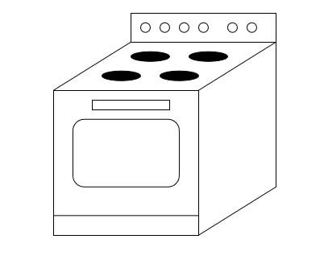

Image 2: New Microwave

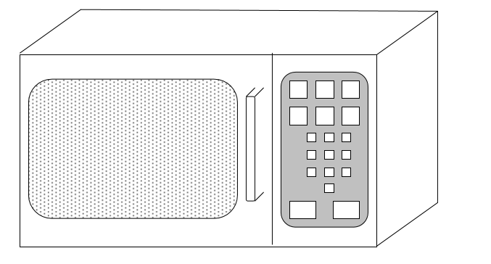

**Are we Robots? Activity**

Instructions: Below is a list of machines that you may encounter in your daily life. Add machines to the bottom. Complete the table by deciding if the machine meets the criteria for being a robot. Then determine if the machine is a robot.

Body—physical form of some kind Control—

Input—gets information from sensors, buttons, etc.  
Program—Is programmable, follows a set of instructions you give it

Output—an action it takes

Behavior—what it does; the function it performs

|  |  |  |  |  |  |
| --- | --- | --- | --- | --- | --- |
|  | Body | Input | Program | Output | Is it a robot? |
| Stove |  |  |  |  |  |
| Microwave |  |  |  |  |  |
| Radio |  |  |  |  |  |
| ipod |  |  |  |  |  |
| Flashlight |  |  |  |  |  |
| Bicycle |  |  |  |  |  |
| Car |  |  |  |  |  |
| Alarm Clock |  |  |  |  |  |
| Traffic light |  |  |  |  |  |
| Photocopier |  |  |  |  |  |
| Mars Rover |  |  |  |  |  |
|  |  |  |  |  |  |
|  |  |  |  |  |  |
|  |  |  |  |  |  |
|  |  |  |  |  |  |
|  |  |  |  |  |  |